Atanas Delevski

ECE 407 HW #8

4/26/2020

Question 1: (I did by hand on paper)

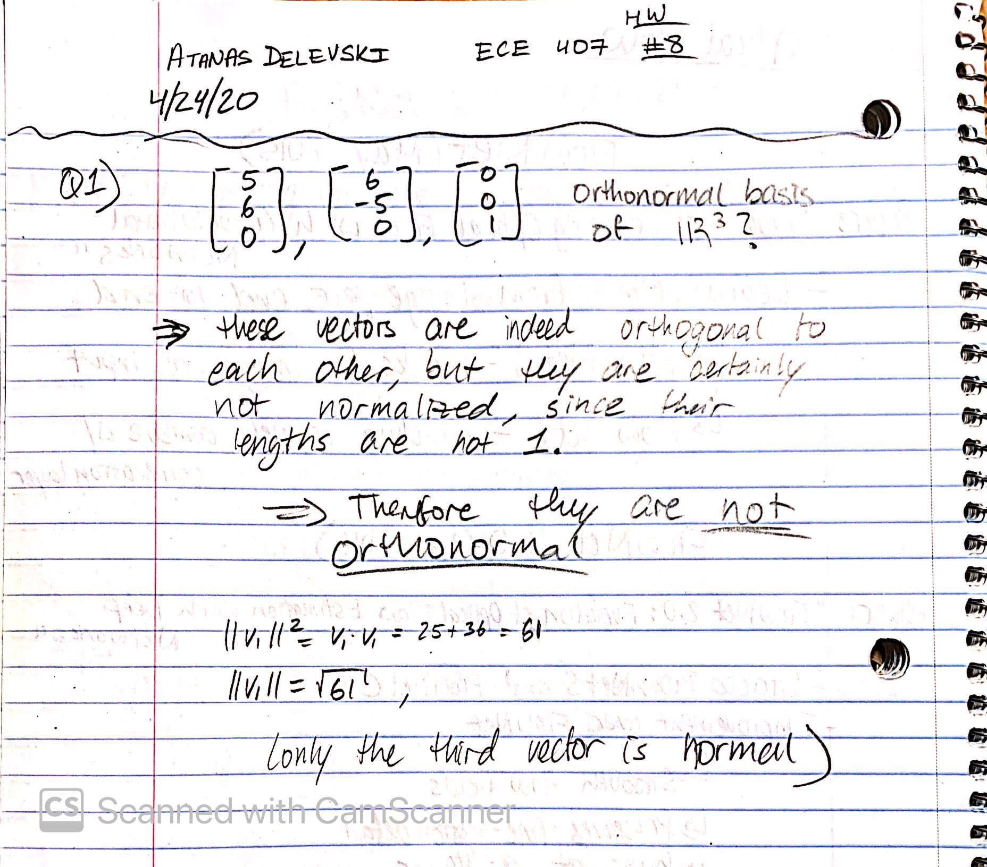

Question 2:

The first eigenvector is the axis of most variation (green). The second eigenvector is the axis with the second most variation (yellow). 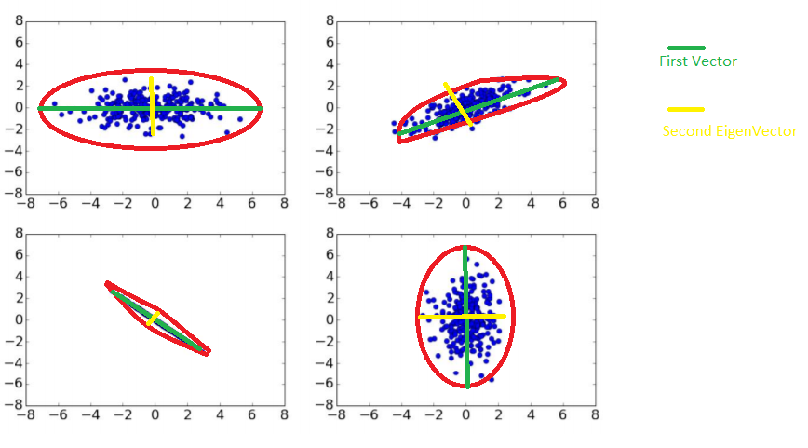

Note: in the bottom left data-set, the line of data points were so perfectly straight that one could say they were 1-D, and therefore it is not possible to fit the second eigenvector (yellow) since there is no second axis of variation.

Question 3: (I did electronically in One Note)

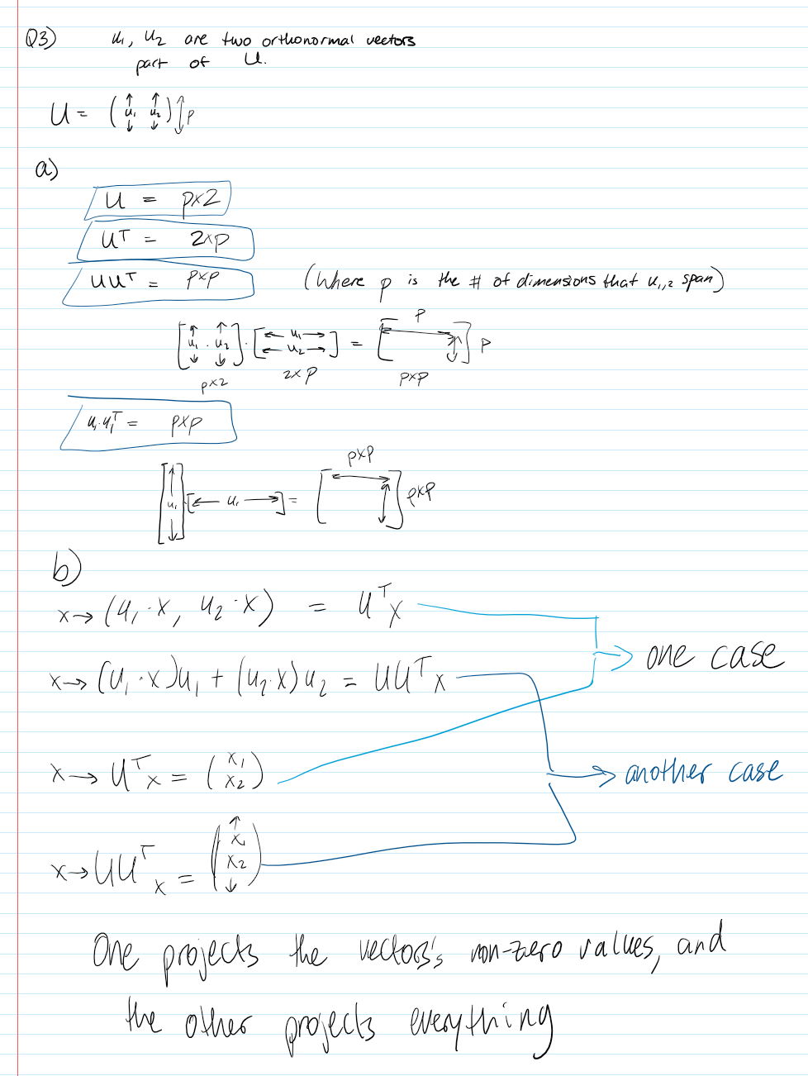

Question 4:

I used a variety of tools to solve this question.

First, I used python to get my covariance matrix.

import pandas as pd

data = pd.read_excel('D:\Python\School\ECE407\HW8\data2.xlsx')

df = pd.DataFrame(data)

x = df.cov()

print(x)

**X Y**

**X 4.707736 3.912738**

**Y 3.912738 4.215650**

Then, I used wolfram alpha to calculate my eigenvectors and eigenvalues from the covariance matrix.

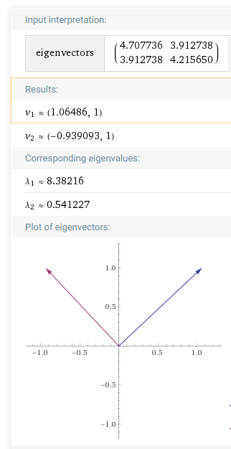

Therefore, the eigenvalues are: **8.38**, **0.54** and the

Eigenvectors are **[1.06, 1]^T**, **[-0.939, 1]^T**

This is showing the top two directions of variance within the dataset. One is along the positive correlation axis between x and y, and the other is along the negative correlation axis between x and y.